Приложение 1
Гуманитарный проект государственного учреждения
«Детско-юношеская спортивная школа №1» г.Слонима
ищет спонсоров.

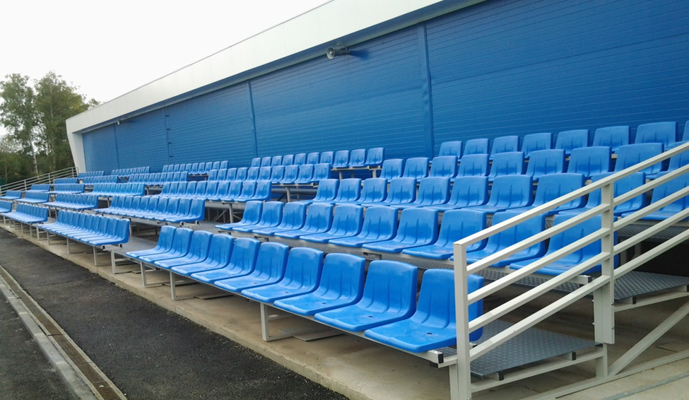
Цель проекта:
- Улучшение условий для занятий физической культурой и спортом населения микрорайона и учащимися школы.
- Улучшение эстетического вида акватории реки Щара и микрорайона «Военный городок».
- Наименование проекта: «Улучшение эстетического вида и функциональных характеристик стадиона по улице Черняховского».
- Срок реализации проекта: 9-12 месяцев
- Организация - заявитель, предлагающая проект: государственное учреждение
« Детско-юношеская спортивная школа №1» г.Слонима.
4.Цели проекта:
- Улучшение условий для занятий физической культурой и спортом населения микрорайона и учащимися школы.
-Улучшение эстетического вида акватории реки Щара и микрорайона «Военный городок».

5. Задачи, планируемые к выполнению в рамках реализации проекта:
Задача №1- Демонтаж старых и установка новых трибун на стадионе ;
Задача №2- Замена ограждения и необходимого оборудования на стадионе;
Задача №3 -Установка контейнерной площадки для сбора бытовых отходов;
6. Целевая группа: подростки до 15 лет, молодежь от 16 до 26 лет, пожилые люди от 60 лет.
7. Краткое описание мероприятий в рамках проекта:
-разработка архитектурного проекта стадиона по улице Черняховского
-Демонтаж старых забора и трибун ,установка новых металлических.
-Ремонт фасада , внутренних помещений ,раздевалок ,санитарных узлов здания стадиона.
8. Общий объем финансирования (в долларах | США): 100 000
Источник финансирования | Объем финансирования (в долларах США)
Средства донора | 99 500
Софинансирование | 500
9. Место реализации проекта (область/район, город): 231800 Гродненская область г. Слоним ул. Пушкина,57/1
10. Контактное лицо:
Марутик Юрий Владимирович - директор государственного учреждения «Детско-юношеская спортивная школа№1 г.Слонима» тел. 80156263951
Моб.+375292841629, email: dush167@mail.ru
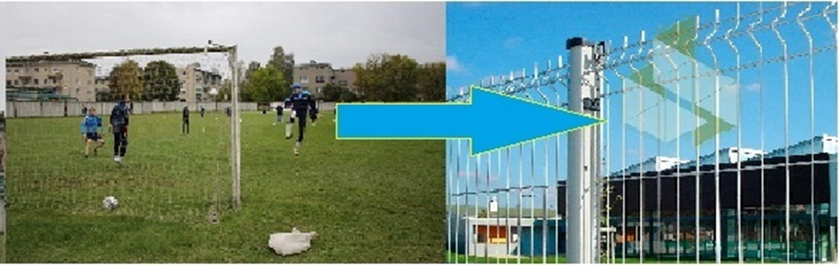
Будем рады сотрудничеству!

Humanitarian project
State institution "Children's and youth sports school No. 1" in Slonim.
looking for sponsors.

Project objective:
- Improvement of conditions for physical culture and sports activities of the population of the district and school students.
- Improvement of the aesthetic appearance of the water area of the Shchara river and the Military town microdistrict.
1. Project name: "Improving the aesthetic appearance and functional characteristics of the stadium on Chernyakhovsky street".
2. Project implementation period: 9-12 months
3. Organization, which offers a project: state institution "Children's and youth sports school No. 1" in Slonim
- Aim of the project:
- Improvement of conditions for physical culture and sports activities of the population of the district and school students.
- Improving the aesthetic appearance of the Shchara river water area and the Military town microdistrict.
5. Tasks to be realized while the project implementation:
Task #1-Dismantling the old stands and installing new ones at the stadium ;
Task #2-Replacement of fencing and necessary equipment at the stadium ;
Task #3-Installation of a container platform for collecting household waste.
6. Task group: teenagers up to 15 years old, young people from 16 to 26 years old, elderly people from 60 years old.
7. Brief description of the events within the framework of the project:
-Development of the architectural design of the stadium on Chernyakhovsky street. Dismantling of old fences and stands ,installation of new metal ones.
- Repair of the facade, interior rooms ,changing rooms, sanitary units of the stadium building.
8. Total funding (dollars USA): 100 000
Source of funding | Amount of financing  (dollars USA)
Contributor | 99 500
Co-financing | 500
9. Place of the project implementation (region/district, town): 231800 Grodno region Slonim ul. Pushkin, 57/1
10. Contact person:
Yuri V. marutik-Director of the state institution "Children's and youth sports school No. 1 in Slonim" tel. 80156263951
Mobile+375292841629, email: dush167@mail.ru

We look forward to collaborating!

